Scheme of work for managing Equality and Diversity (EO&D), British Values, Prevent and Safeguarding Discussions in Apprentice Progress Reviews

The following sheets set out the key themes to be discussed during learner progress reviews.

Where a naturally occurring opportunity is identified that can be used to extend the learners working knowledge of EO&D or Safeguarding, this should take priority over the setting of a pre-planned worksheet.

In many cases, it is expected that relevant worksheets can be used to support the learner’s development and application of knowledge relevant to real life situations that they encounter during their work as an apprentice.
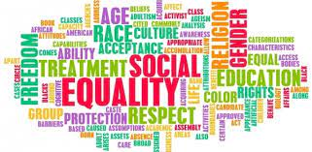

Sheet | EO&D and Safeguarding | Aspects to discuss | Apply to work environment
1 | Glossary of terms | Brief introduction to the terms in use that reflect equality and diversity in the workplace. | Raise awareness relative to the workplace with a view to informing and protecting both the learner and the employer.
2 | Discrimination | Different forms of discrimination in the workplace. | Link to how the workplace complies and what specific action an apprentice would take if they felt discriminated against.
3 | British Values | What fundamental British values are and opportunities to develop your knowledge | Encourage learners to challenge stereotypes. Learn to recognise and understand perceptions in the workplace.
4 | Bullying & harassment | Definitions of bullying and harassment, behaviours that can lead to it, how not to be a victim. | Ensure the learner is competent to recognise the symptoms, personally or in others, and are aware of reporting procedures.
5 | Disabilities | Broad understanding of different disabilities that individuals may have. | Developing a better understanding of how learners will understand, support and work with those with disabilities.
6 | Victimisation | Identify the difference between discrimination and victimisation | Ensure that learners are aware of how to report any suspected instance of victimisation, without endangering their own position.
7 | Stereotype | Definition of stereotyping and how it impacts on individuals, groups and cultures. | Being able to identify possible instances of stereotyping at work and understand what the learner can do to discourage this.
8 | Sexual orientation, gender reassignment | Identify sexual orientation and rights protected in law to clarify understanding for learners | Support learners in understanding sexual orientation and trans gender issues in the workplace.
9 | Culture and Religion | Diversity of religions and beliefs learner may meet in the workplace, awareness of discrimination. | Learners understand everyday aspects of dealing with religious cultural differences, e.g. eating preferences, prayer requirements, etc
10. | Age Discrimination | Define what is meant by Age Discrimination in the workplace and what protection is offered by the Equality Act 2010. | Learners can identify the different types of age discrimination that can occur in the workplace and can differentiate between lawful and unlawful discrimination.
11. | Prevent and Channel | Define Prevent and Channel, why they exist and what learners should do if they have concerns about radicalisation. | Learners understand the importance of Prevent and can identify what action to take if they have concerns relating to issues of possible radicalisation in the workplace or in study sessions.
Scheme of work for managing Equality and Diversity (EO&D) and Safeguarding discussions in Apprentice Progress Reviews

12. | Internet and Online Safety | Identify the main issues that can pose a risk when working Online and using the Internet. Define actions that can be taken to mitigate these risks. | Learners understand and apply appropriate techniques to safely manage the potential risks of online working in the workplace, in learning and in social use.
13. | Healthy Relationships | Identify what makes a healthy relationship and what constitutes as consent with regards to the law. | Learners understand and can identify what is consent and sexual harassment and what to do.

Worksheet 1
Promoting Equality & Diversity in Apprenticeships – Glossary of Terms
Below is a list of terms you are likely to hear at work. It is important that you have a good understanding of how these terms could apply to you in your everyday work as you may be personally affected or you may be working with someone who is affected.
Disability: A disabled person is described in the Equality Act 2010 as one who has a physical or mental impairment, which has a substantial and long-term adverse effect on his or her ability to carry out normal day-to-day activities.
Diversity: Diversity is about recognising, valuing and taking account of people's different backgrounds, knowledge, skills, and experiences, and encouraging and using those differences to create a productive and effective workforce.
Ethnicity: A group regarded as a distinct community by virtue of certain essential characteristics – a shared history which distinguishes it from other groups and a cultural tradition of its own. Sikhs and Gypsies are examples. However, it has come to have a broader meaning and the expression ‘ethnic monitoring’ is used in reference to groups defined by colour, race or national origin as well.
Gender: The word 'gender' is often used in place of the word 'sex' in equality issues. 'Gender' does not appear in legislation (except for 'gender reassignment' - see below) but 'sex discrimination' and 'gender discrimination' are generally interchangeable.
Gender Reassignment: Gender reassignment is a process undertaken under medical supervision for the purpose of reassigning a person's sex by changing physiological or other characteristics of sex. It is unlawful to discriminate in employment on the grounds of an employee intending to, undergoing or having undergone, gender reassignment.
Genuine Occupational Requirements: The Equality Act allows for circumstances where a person's sex, racial group, religion or sexual orientation is a genuine requirement for a particular job.
Harassment: Behaviour which is unwelcome or unacceptable and which results in the creation of a stressful or intimidating environment for the victim amounts to harassment. It can consist of verbal abuse, racist jokes, insensitive comments, leering, physical contact, unwanted sexual advances, ridicule or isolation.
Sexual orientation: Whether a person is attracted to people of their own sex, the opposite sex or both sexes. Law also covers assumptions and perceptions of a person’s sexual orientation.
Transsexual: A person with gender dysphoria who feels a consistent and overwhelming desire to live their life in the gender that is opposite to that assigned to them at birth.
Victimisation: If a person has made or is making an accusation of discrimination in good faith, it is unlawful to discriminate against them for having done so, or because they intend to do so or it is suspected that they intend to do so.
Questions
- Select three of the definitions given in the glossary and explain how they could impact on you or other colleagues at work?

- How does your employer ensure everyone is treated appropriately for who they are, and unlawful discrimination does not occur?

Worksheet 2
Promoting Equality & Diversity in Apprenticeships – Discrimination


In order to promote equality and diversity in the workplace, employers should have a written equality and diversity policy. Employees may hold a business owner or manager responsible for any discriminatory action if it is not possible to show that appropriate steps were taken to try and prevent such action occurring. As an employee, you should be aware of discrimination at work and ensure you comply with your employers’ policy and do not partake in any action that may be discriminatory towards work colleagues. There are different forms of discrimination at work that cover: race, religion or belief, sexual orientation, sex, marriage and civil partnership, age, disability, gender reassignment and disability. These are known as protected characteristics.
Direct discrimination - Direct discrimination occurs when someone is treated less favourably than another person because of a protected characteristic they have or are thought to have or because they associate with someone who has a protected characteristic.
Discrimination by association - This is direct discrimination against someone because they associate with another person who possesses a protected characteristic.
Perception discrimination - This is direct discrimination against an individual because others think they possess a particular protected characteristic. It applies even if the person does not actually possess that characteristic.
Indirect discrimination - Indirect discrimination can occur when you have a condition, rule, policy or even a practice in your company that applies to everyone but particularly disadvantages people who share a protected characteristic. Indirect discrimination can be justified if you can show that you acted reasonably in managing your business, i.e., that it is ‘a proportionate means of achieving a legitimate aim’.
An example of indirect discrimination
A small engineering company needs its staff to work late on a Friday afternoon to finish a quote for its American parent company. The figures arrive late on Friday because of the global time differences. During the winter, some staff would like to be released early on Friday afternoon in order to be home before sunset – a requirement of their religion. They propose to make the time up later during the week. The company is not able to agree to this request because the American figures are necessary to the business; they need to be worked on immediately and the company is too small to have anyone else able to do the work. The requirement to work on Friday afternoon is not unlawful indirect discrimination as it meets a legitimate business aim and there is no alternative means available.

Questions
- What is the Equality Act and how does your company comply with it?
- If you felt you were being treated unfairly at work, what actions would you take?
- What is meant by a ‘protected characteristic’?
- How could you discourage another learner or colleague from sharing views which are racist? If this did occur, would you report this behaviour?

Worksheet 3
Promoting Equality & Diversity in Apprenticeships – British values
The government set out their definition of British values in the 2011 Prevent Strategy. These were reinforced in September 2014 and sit alongside the requirements of the Equalities Act.
Fundamental British values are:
- Democracy
- The rule of law
- Individual liberty and mutual respect
- Tolerance of those with different faiths and beliefs

Some examples of how you can develop and apply your knowledge of British values while working through your apprenticeship programme include:
- Contributing to the development of ground rules during courses you attend.
- Understanding and adhering to your employers and training provider’s behaviour policy.
- Becoming an independent learner.
- Understanding your employer’s mission and values statement.
- Constantly promoting respect for others.
- Valuing the opinions of others during discussions (This does not mean you have to agree).
- Supporting charitable work.
- Learning about other faiths and beliefs.
- Taking part in activities that allow you to express your views relating to your employment and training, Such as questionnaires and learner/ employer forums.
- Understanding the importance of the law and recognising these laws are for your own protection and the benefit of wider society.
- Making use of the ‘safe’ environment you work and study in.
- Develop working relationships built on mutual respect with other learners, your employer and the training staff who work with you.
- Striving to become a more knowledgeable and understanding citizen who can contribute to building a better society for the future.
The fundamental British values, of democracy, the rule of law, individual liberty and mutual respect and the tolerance of those with different faiths and beliefs, apply to all individuals in the United Kingdom.

SIGTA support British values and translate these into our organisational values

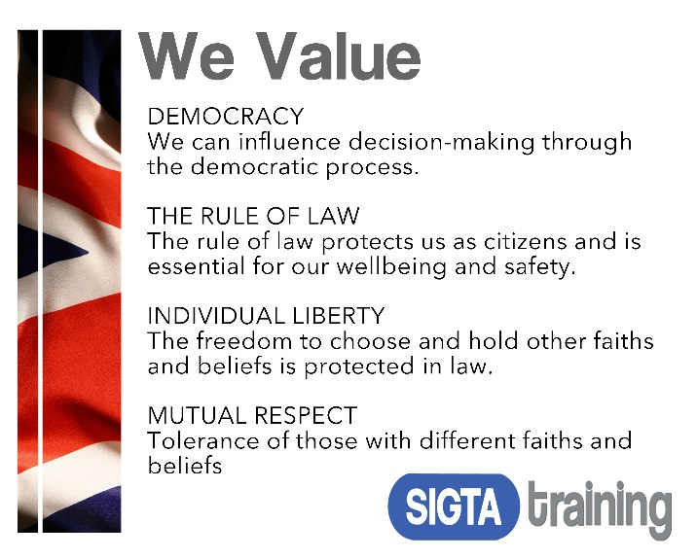
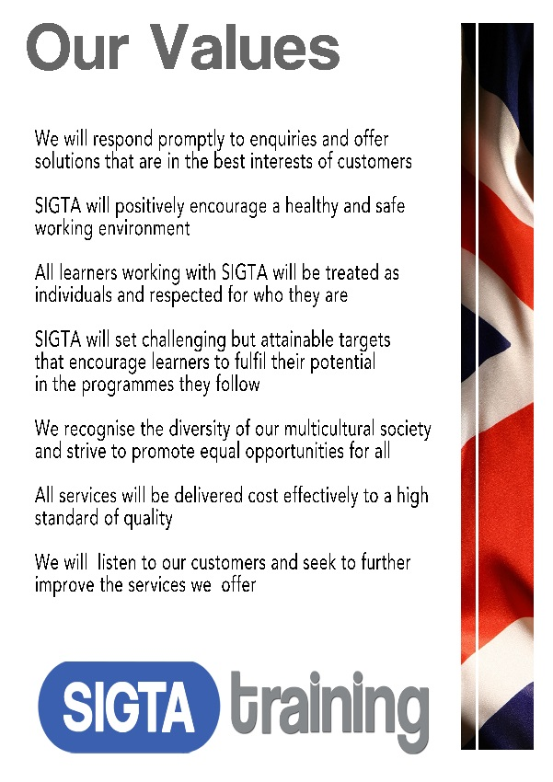
Questions
- Give a detailed example of how you feel British values contribute to your apprenticeship?

- Give 3 examples of how you think you apply British values within your workplace?
- Does your organisation have a published list of organisational values? If yes, describe how these link to fundamental British Values. If not, write your own list of values that could be used
by your organisation and show how they link to British values.

Worksheet 4
Promoting Equality & Diversity in Apprenticeships – Bullying and Harassment
Bullying and harassment of any kind are in no-one’s interest and should not be tolerated in the workplace or training centre, but if you are being bullied or harassed it can be difficult to know what to do about it.

Harassment is:
- Unwanted conduct, which has the purpose or effect of violating an individual’s dignity or creating an intimidating, hostile, degrading, humiliating or offensive environment for that individual.
Bullying may be characterised as:
- Offensive, intimidating, malicious or insulting behaviour; an abuse or misuse of power through means that undermine, humiliate, denigrate or injure the recipient.
Bullying or harassment may be by one individual against another individual (perhaps by someone in a position of authority, such as a manager or supervisor) or involve groups of people. It may be obvious or it may be insidious. Whatever form it takes, it is unwarranted and unwelcome to the individual.
Examples of bullying/harassing behaviour include:
- Spreading malicious rumours or insulting someone by word or behaviour (particularly on the grounds of age, race, sex, disability, sexual orientation and religion or belief).

- Ridiculing or demeaning someone – picking on them or setting them up to fail.

- Exclusion or victimisation, unfair treatment, overbearing supervision or other misuse of power or position.

- Unwelcome sexual advances – touching, standing too close, the display of offensive materials, asking for sexual favours, making decisions on the basis of sexual advances being accepted or rejected.

- Making threats or comments about job security without foundation.

- Deliberately undermining a competent worker by overloading and constant criticism.

- Preventing individuals progressing by intentionally blocking promotion or training opportunities.
Bullying and harassment are not necessarily face-to-face. They may also occur in written communication, email, text messaging or more commonly now by social media.

Bullying and harassment can make someone feel anxious and humiliated. Feelings of anger and frustration at being unable to cope may be triggered. Some people may try to retaliate in some way. Others may become frightened and demotivated. Stress, loss of self-confidence and self-esteem caused by harassment or bullying can lead to job insecurity, illness, absence from work, and even resignation. In some extreme cases the result of bullying and harassment can have life threatening consequences.
An example of bullying and harassment
Steve is continually being called gay and other related names by a group of employees at his work. People from this group have posted derogatory homophobic comments on the staff noticeboard about him. Steve was recently physically pushed to the floor by one member of the group but is too scared to take action. Steve is not gay but heterosexual; furthermore, the group knows he isn’t gay. This is bullying and harassment related to the perception of sexual orientation.

All occurrences of bullying and/ or harassment are wrong. They must be reported and stopped.

Question
What would you do if you were the victim of bullying or harassment at work or if you observed it happening to someone else?

Worksheet 5

Promoting Equality and Diversity in Apprenticeships – Disabilities
In the last few decades, understanding and acceptance of people with disabilities has greatly improved as medical research has enlightened society in general to the types and effects of different conditions. Many people with disabilities have gone on to achieve great things. People such as:


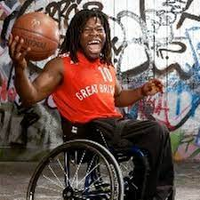

Steve Jobs
The Apple founder suffers from dyslexia.
Katie Piper
The victim of a vicious acid attack in March 2008, Katie has endured more than 250 surgical procedures to date.
Ade Adepitan
wheelchair basketball player

It is unlawful to discriminate against people because of a physical or mental disability or fail to make reasonable adjustments to accommodate an employee with a disability. Under the Equality Act 2010, a person is classified as disabled if they have a physical or mental impairment which has a substantial and long-term effect on their ability to carry out normal day-to-day activities. Day-to-day activities include things such as using a telephone, reading a book or using public transport.
Employers must make reasonable adjustments to make sure disabled workers (including contract workers, trainees, apprentices and business partners) aren’t seriously disadvantaged when doing their jobs.
This includes:
- Making reasonable adjustments during the recruitment process.
- Doing things another way - e.g., allowing someone with social anxiety disorder to have their own desk instead of hot-desking.
- Making physical changes - e.g., installing a ramp for a wheelchair user or an audio-visual fire alarm for a deaf person.
- Letting a disabled person work somewhere else - e.g., on the ground floor for a wheelchair user
- Changing their equipment - e.g., providing a special keyboard if they have arthritis
- Allowing employees who become disabled to make a phased return to work - e.g., working flexible hours or part-time.
- Offering employees training opportunities.

Some people have disabilities that are easily recognised others have disabilities that are not obvious, such as:
Dyslexia - The condition may be evident in a difficulty in reading, but in the case of adults, not always; there may be a slowness with reading and difficulties with spelling, syntax, putting thoughts down in formal writing e.g. essay writing/report writing, assimilating or retaining information.
Dyspraxia - This often presents difficulties with visual spatial and coordination tasks and may affect gross and fine motor movements e.g. tying shoelaces, handwriting, learning to drive a car/ride a cycle, wrapping a parcel. People may also be sensitive to sound and may not always pick up on subtle or non-verbal communications.
Dyscalculia – This is a condition that affects a person’s ability to acquire arithmetical skills. They may have difficulty understanding simple number concepts, lack an intuitive grasp of numbers, and have problems learning number facts and procedures.
Asperger’s / Autism - Those who are autistic or have Asperger’s Syndrome may have trouble with social interaction skills. This may be evident in a variety of ways including difficulty making friends or inappropriate use of jokes in conversation. It can also present difficulties in distinguishing between essential and non-essential tasks and managing changes to routine. It is important to be very explicit when giving instructions (which task should be done first, what they should then do and then they should come back to ask for other tasks when these are finished). As much notice as possible with change. They may also have difficulties with filtering out background visual and auditory information.
ADHD / ADD - This refers to attention-deficit hyperactivity disorder which may also occur without hyperactivity. This condition often receives bad press coverage, used inappropriately when behaviour is attributed to this condition but it is more likely to be a result of difficult family background or parenting issues. This can result in those who have the condition not getting the best response. Jobs best suited to this type of condition are those with a lot of variety, which is easier than being attentive on one task for a long time. It also helps to have a physical component to the job.
An example
If the garage has a job that requires a lot of heavy manual handling, they could ask a candidate with mobility impairment whether they could manage handling heavy goods and what reasonable adjustments could be made. However, the garage would not be able to ask the person how their impairment would affect them in getting to the workplace, because this is not something that is intrinsic to the job itself.

Questions
- You have been asked to mentor a young person on work experience from school who has a disability. What information would you require and what support would you need to be able to manage this?

- Consider a typical job you undertake as an apprentice and explain what reasonable adjustments could be made to assist a learner with a mobility difficulty who uses a wheelchair?
Worksheet 6

Promoting Equality & Diversity in Apprenticeships – Victimisation
If someone complains about discrimination at work and feels that they are being singled out for treatment that is different from others doing a similar job – in other words, they may feel ‘picked on’ because of the complaint, this is victimisation. Victimisation is the less favourable treatment of someone compared to their peers because they, in good faith, have complained (whether formally or otherwise) that someone has been bullying or harassing them or someone else, or supported someone to make a complaint or given evidence in relation to a complaint.

The difference is that while discriminatory actions are possibly based on, for example, age, disability, race, religion, sex or sexuality, victimisation is unfair treatment because of other issues. Complaining, insisting on legal rights at work or doing anything that is legal and justified within the law that is followed by unfair treatment can be victimisation. Let’s say you have supported a colleague in a discrimination complaint and are treated unfairly, this amounts to victimisation.

Victimisation is often extremely difficult to pinpoint and prove but can often be sorted out quickly in an informal way. If this is not possible, the next step is to raise a grievance with the employer. This has to be done in writing. If this does not solve the problem, the employee can make a claim to an employment tribunal. There is a three-month time limit for making a claim to an employment tribunal, which runs from the date that the victimisation took place.
This list is not exhaustive but illustrates inappropriate actions (Victimisation) that could be taken as a result of an employee’s legitimate action in relation to a valid complaint or issue:
- Employer disciplines or dismisses the employee
- Colludes to deny the employee the usual overtime opportunities or a bonus scheme
- Enforces petty rules which were previously overlooked
- Unreasonably refuses to agree holiday dates
- Unreasonably excludes the employee from important meetings
- Marginalises the employee
- Pressurises the employee to drop the allegation
- Threatens the employee with damage to his/her career if he/she persists with the allegation.

Bullying, harassment or victimisation are not necessarily carried out face to face and may be by written communications, text, email, and telephone or by the recording of telephone conversations if this is not universally applied to all workers. All work performance measures should be introduced in an open manner and must be applied consistently to all staff working within the same area.
Question
What is the procedure within your own company to report and deal with instances of possible victimisation?

Worksheet 7
Promoting Equality & Diversity in Apprenticeships – Stereotyping
A stereotype is a thought that someone has about specific types of individuals that may or may not accurately reflect reality. Stereotypes can also be thought of like caricatures, which are pictures that exaggerate certain features while oversimplifying others and end up distorting the essence of an individual. Many stereotypes are widely held but they are also overgeneralised images or ideas about a particular type of person. Any time we group individuals together and make a generalisation or judgment about them without knowing them, this is an example of a stereotype.
A prejudice is an opinion - usually an unfavourable one - that was formed before having any evidence and that is not based on reason or experience. While a stereotype is a thought about a person or group of people, a prejudice relates to feelings and attitudes about that person or group of people. Prejudices are often rooted in the idea that certain types of people are worth less or are less capable than others.
When we have expectations or feelings about people based on characteristics like race, gender, or sexual orientation we may act in ways that negatively affect individuals or groups of people. Often, we don’t even think about the stereotypes or prejudices we hold and may hurt or disadvantage people without realising it. We may think that we are simply behaving in ways that accurately reflect the realities or abilities of different groups but we are actually discriminating. Even if a stereotype is seen as or meant to be positive, the fact that not all persons in that group meet that standard often leads to a “positive” stereotype that inadvertently disadvantages other individuals.
Stereotypes and prejudices are harmful because they ignore the fact that everyone has his or her own abilities, strengths, weaknesses, desires, thoughts and feelings.
Stereotypes don’t just try to describe what people are like; they also define what they should be like or what role they should have based on characteristics such as race, gender, or sexual orientation. Prejudices also lead people to make value judgements and assume what people can or cannot do because of who they are. All of this leads to discrimination and limits equality of opportunity.
Some studies have even shown that when people are aware of specific stereotypes about themselves - for example, that girls are bad at maths or that men are not good communicators - that knowledge affects their perceptions of their own abilities and their performance.
To combat stereotypes and reduce prejudices we can all try to learn more about people, especially those who are different from us, and understand and value our similarities and our differences. If we are more conscious of our assumptions, we can also choose how we respond – within our families and home lives; in the workplace and in other relationships and positions that we have and hold.
Questions
- Give an example of where people may be stereotyped in your workplace.
- How could you work to discourage this?

Worksheet 8
Gender Reassignment and Sexual Orientation Discrimination
Under the Equality Act 2010, it is unlawful to discriminate against workers because of sexual orientation.
Sexual orientation is defined as:
- Orientation towards people of the same sex (lesbians and gay men)
- Orientation towards people of the opposite sex (heterosexual)
- Orientation towards people of the same sex and the opposite sex (bisexual)

It is unlawful to discriminate against a person on the grounds that they have undergone, are undergoing, or intend to undergo, gender reassignment, with limited exceptions in recruitment. It is also unlawful to treat such a person less favourably than a person who is off sick for another reason and similar period.
Transgender people may face discrimination and prejudice across their life course and will often experience high levels of abuse before transitioning due to a rejection of their gender at an early age. In this way, many Transgender men and women will experience homophobic attitudes (because of how society expects their gender to behave) before transitioning and experiencing both transphobic and homophobic attitudes during and after transitioning.

In regard to transgender equality issues, the Equality Act 2010 provides the following:
- In the Equality Act 2010, ‘gender reassignment’ is named as an explicit protected characteristic, alongside age, disability, marriage and civil partnership, pregnancy and maternity, race, religion or belief, sex and sexual orientation.

- The requirement for medical supervision to take place as part of a process of 'gender reassignment' has been removed so someone who simply changes the gender role in which they live without ever going to see a doctor is protected.

- All the main protections which already existed for gender reassignment are carried over from the previous Sex Discrimination Act legislation – e.g. protection from gender reassignment discrimination in employment and goods and services. The previously existing exceptions are also carried over.

- The Equality Bill offers new protection from discrimination due to association with transsexual people or perception as a transsexual person.

- It also offers new protection from indirect discrimination because of gender reassignment.

Question
You are asked to deal with a customer who is transgender. Would you treat this person differently to a non-transgender customer? Please fully explain your answer.
Worksheet 9
Promoting Equality & Diversity in Apprenticeships – Religion and Belief
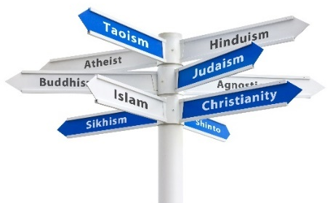
This worksheet illustrates basic information about some of the main religious and cultural lifestyles found in the UK. It is illegal to discriminate against anyone on the grounds of their religion or belief; you need to be aware of these cultural differences and ensure you are not involved in discrimination.
Christianity is based on the life and teachings of Jesus of Nazareth, as presented in the New Testament. Christians generally believe Jesus is the Son of God; being a true Christian is about accepting Jesus as Saviour and using the Bible as a guide for living. The main Christian festivals are Christmas and Easter. Christian dietary habits tend to be culturally rather than religiously determined. However, some Christians may avoid pork and /or alcohol.
Islam refers to the religion taught by the Islamic prophet Muhammad. Islam is the dominant religion of many Asian countries and is generally categorised as Sunni and Shia. The Holy Book is the Quran, which contains the laws of Islam. In Islam, all food is classified as either halal (lawful) or haram (prohibited). Pork and alcohol are absolutely forbidden. Devout Muslims will pray a number of times per day and must perform ablutions before prayers can commence. Every Muslim adult is required to fast during Ramadan, where they must abstain from food and drink from dawn to sunset for one lunar month.
Hinduism - Hindus uphold the sacredness of all life, including animal life. Devout Hindus will neither eat meat nor fish. Some will not eat eggs. Even those Hindus who have decided to eat meat will nonetheless refuse to eat beef since the cow is seen as a sacred animal. Hinduism forbids the consumption of alcohol. Hindus celebrate many festivals and are particularly zealous to celebrate Deepawali (also known as Diwali), the autumn festival of lights that also marks the start of the New Year.
Sikhism - A Sikh must have the courage to defend the rights of all who are wrongfully oppressed or persecuted irrespective of religion, colour, caste or creed. Sikhism forbids smoking and the consumption of alcohol. A devout Sikh will neither eat eggs nor any animal by-product and many do not eat meat. Sikhs regard the cow as a sacred animal and eating pork is prohibited. The central festival is Vaisakhi. Sikhs also celebrate Diwali, the festival of lights. Sikh men are religiously required to wear turbans to cover their uncut hair.
Judaism - Judaism is considered by religious Jews to be the expression of a relationship with God developed with the Children of Israel where he revealed his laws and commandments to Moses. The main festival is Hanukkah, also known as the festival of lights. The Halakha necessitates Jews to refrain from work on the Sabbath (our Saturday). Jews are religiously obliged to eat kosher food. Meat and dairy products must not be eaten in the same meal. Pork is forbidden to Jews.

Question

- What are the main symbols used to represent the above religions?

- Assume you have a work colleague who practices one of the above religions that you are not very familiar with (select one of your choice). To enable you to better understand your colleague beliefs, research this religion further and produce a one page information sheet setting out useful information and key facts about the religion you have selected.
Worksheet 10
Promoting Equality & Diversity in Apprenticeships – Age Discrimination

Age discrimination, which is often referred to as ‘ageism,’ occurs when an individual is treated unfavourably due to their age.
This guide focuses on age discrimination that may be experienced at work and the protection offered by the law.
Equality Act
Under the Equality Act 2010, it is illegal for an individual to be subjected to age discrimination in any aspect of employment including:
- Recruitment
- Employment terms and conditions
- Promotions and transfers
- Training and dismissals.
The Act provides protection from four types of discrimination:
- Direct discrimination: for example, an employer says they will not promote an employee because they are too young or to old.
- Indirect discrimination: for instance, an employer offers a training course exclusively to recently qualified apprentices thereby potentially excluding older workers.
- Harassment: for example, work colleagues make jokes about the age of an employee that are offensive.
- Victimisation: for instance, after an employee makes a statement supporting a colleague’s age discrimination complaint, they are bypassed for a promotion that they would otherwise have been given.
Direct discrimination
Direct discrimination can arise by someone treating an employee less favourably because of:
- Their actual age (direct discrimination)
- Their perceived age (direct discrimination by perception)
- The age of someone they associate with (direct discrimination by association).
Although the Equality Act protects individuals from workplace discrimination, there is an exception where an employer can reach a decision based on age if they can demonstrate that it is objectively justified and proportionate. This is only permitted in a limited number of situations and does not mean that employers can discriminate on the basis of age on a whim.
One instance of when age discrimination can be objectively justified is when undertaking a physically demanding role and an employee is forced into retirement when they reach a certain age for health and safety reasons. This would also apply if the law prevented a younger person performing a particular role. For example the law specifies a minimum age for someone to drive a Large Goods Vehicle.
Direct discrimination on the grounds of actual age is the only one of the three forms of direct discrimination that can be objectively justified as a proportionate means of achieving a legitimate aim. This discrimination must be:
- Proportionate
- Appropriate
- Necessary.
Economic factors, such as business needs and efficiency, may be considered legitimate aims.
Whilst an employer may be able to justify discrimination, they can never justify harassment or victimisation.
Indirect discrimination
Indirect discrimination can take place where there is a workplace policy, practice, procedure or rule that applies to all workers, but especially disadvantages people of a certain age.
For example, a requirement for internal job applicants to have worked in a certain industry for 10 years may disadvantage younger candidates.
In some circumstances, indirect discrimination may be justified if it is a proportionate means of achieving a legitimate aim.

Questions
- Give two example of unlawful age discrimination?
- Give one example of lawful direct or indirect age discrimination?

Explain your answers

Worksheet 11
Prevent and Channel

What is Prevent?
Prevent was created to respond to a range of threats faced in the UK from different forms of terrorism.

What is the Threat?
The threat to the UK and our interests overseas from international terrorism is severe. Experience demonstrates that the threat comes not just from foreign nationals but also from individuals born and bought up in Britain. It is therefore vital that the UK counter-terrorism strategy contains a plan to prevent radicalisation and stop would-be terrorists from committing mass murder. Prevent is one of four parts of the government’s counter-terrorism strategy CONTEST; these are:

- Prevent | - Pursue | - Protect | - Prepare

The process of Prevent has five stages known as Channel: (Channel, Referral, Preliminary Assessment, Multi-Agency Panel, and Support). Channel is explained more fully later in this worksheet.

What is the objective of Prevent?
Prevent aims not only to stop people becoming terrorists but to challenge and prevent support of terrorism, radicalisation and extremism, while at the same time protecting the public. This can include tackling those who support a far-right group or who carry out any other extremist activities, as well as those who engage in hate or prejudice-based bullying.
The three key objectives of Prevent are to:
- Respond to the ideological challenge of terrorism and the threat we face from those who promote it.
- Prevent people from being drawn into terrorism and ensure that they are given appropriate advice and support.
- Work with sectors and institutions where there is a risk of radicalisation which we need to address.
Part of the Prevent strategy is to ‘promote British values’, which are covered in a separate worksheet.

How does Prevent affect me as an individual learner?
The aim of Prevent is to safeguard learners from abuse, exploitation and radicalisation. It does not mean that controversial or sensitive issues cannot be discussed and it is not about spying on anyone.

Which organisations have to comply with the Prevent Duty?
Under the Counter Terrorism Act 2015, public bodies and organisations that are government funded and work with the public must comply with Prevent. This includes:
- Schools, Further and Higher Education institutions
- Social workers and children’s services
- Hospitals, GP surgeries and other medical facilities
- Government departments and bodies
- Local councils
- Police force

Prevent is also relevant for other groups such as faith-based organisations and charities. Organisations must demonstrate active engagement with this policy and ensure that staff receive appropriate training. They should also be supported and trained to be aware of what the signs of radicalisation are, how it can happen (for example, through social media), the kinds of people who are vulnerable to radicalisation, and what steps to take if they suspect a learner or member of staff may be involved with extremist activities.
What is Channel?
Channel provides support across the country to those who may be vulnerable to being drawn into terrorism. The overall aim of the programme is early intervention and diverting people away from the risk they may face. Channel uses existing collaboration between partners to support individuals and protect them from being drawn into terrorism.

Who delivers Channel?
The Channel process is a multi-agency approach with a wide range of agencies and local partners working together to provide support for individuals. Coordinators are usually police officers with the multi-agency panel being chaired by the Local Authority.

How does Channel Work?
Channel works by partners (Multi agency panel) jointly assessing the nature and the extent of the risk and where necessary, providing an appropriate support package tailored to the individual’s needs.
The three key stages of Channel are:
- Identify individuals at risk of being drawn into terrorism;
- Assess the nature and extent of that risk; and
- Develop the most appropriate support plan for the individuals concerned.
How are individuals at risk identified?
Referrals come from those who have concerns about individuals who may be vulnerable to being drawn into terrorism.

Who makes the referrals?
Referrals can come from a wide range of individuals and partners and could include youth offending teams, social services, health, police, education and local communities.

Who sits on the multi-agency panel?
The panel is designed to work in the same way as other multi agency structures that are used to safeguard individuals at risk – from drugs, knife and gun crime, gangs etc. The panel is chaired by the local authority and consists of statutory partners and the Channel coordinator.

What kind of support is provided through the Channel?
Examples of support provided could include mentoring, diversionary activities such as sport, signposting to mainstream services such as education, employment or housing. Support is always tailored to the specific needs of the individual, following assessment by the multi-agency panel.

Raising a concern
As a learner on a SIGTA programme, if you believe that someone is vulnerable to being exploited or radicalised, report this immediately to your SIGTA Training Officer or directly to SIGTA’s designated Safeguarding Officer Alison Foxwell the CEO: afoxwell@sigta.co.uk or 01273 416602. If appropriate, your concern will be passed to Channel.

Questions
- What is radicalisation?

- What is the Prevent strategy?

- If you thought another learner or work colleague was involved with an extremist group and had started distributing material expressing extremist views, what action would you take?
Worksheet 12

Internet and Online Safety
The main issues with Internet safety include:
- Avoiding 'net nasties' including: phishing, malware and viruses.
- Avoiding online scams and confidence tricks, Internet fraud and computer crime.
- Avoiding unwelcome sites.
- Avoiding unsuitable and undesirable message exchanging on networking sites, perhaps with people who could be dangerous to the unsuspecting.

Most Internet sites and contacts are genuine and some will need details of your personal information, particularly banks and credit card companies. It is really important in these situations to know you are dealing with genuine websites and not a fraudulent site.

Anyone who uses social networks such as Facebook and Twitter shouldn't give out personal information such as date of birth, address, telephone number etc. to anyone, especially strangers who wish to ‘follow you’ as you will not be sure of their real intent or motive.

It isn’t a good idea to post personal photographs on social network sites that may cause embarrassment later in life. You may well delete them but by then someone else may already have downloaded them!

If you receive an email letting you know you’ve just won a competition, consider, did you actually enter the competition or apply for whatever it is. If not, you haven’t won but you may be asked for your bank details to deposit the prize money or send a fee to receive your prize, quite often the ‘prize’ is your cleaned out bank account!

When out in clubs or bars never hand over your debit or credit card to be kept behind the bar as a guarantee for drinks etc., there are too many opportunities for your card to be cloned.

Tips to stay safe when online

Don’t use lazy passwords
If your account is hacked, it's often because someone has worked out your password. Never use a password that anyone could guess or work out - a middle name, pet's name or favourite football team. Include capital letters, numbers and punctuation for extra security.

And never use the same password for different accounts. That will mean when people can get into one of your accounts, they can access them all.
Be careful what you post online
Everything you write on a social network is public, so don't give out any personal details, such as your address, bank details etc. That would be the equivalent of shouting the details out of the window. Don't write that you are going on holiday, as that leaves you vulnerable to burglars.

Many employers also google prospective employees when recruiting, so don't post anything that could damage your chances of getting a job.

If you are a victim of cyberbullying, do not answer back
The rule for dealing with cyberbullies is to "stop, block and tell". Don't answer back, as that will only feed the abuse, block the person or message and tell someone you trust.
To help avoid and stop online bullying:
- Do speak only for yourself.
- Do be the same friend online as you are in person.
- Do think about the effect your post will have on other people.
- Do report it if you see any of your friends being bullied.
- Don't say anything online you wouldn't say to someone's face
- Don't write it if you wouldn't be happy for your Mum to read it
- Don't respond to anyone who is being negative towards you - don't feed the troll
- Don't write or post anything you aren't 100% happy to be made public - as it will be out there forever. Even if you remove content, it might already have been copied by someone else.
- Don't say anything you wouldn't be happy to have said to you

Never open email attachments or click on links from strangers
Viruses are often spread via attachments in emails, so if you don't know what an attachment is, don’t open it. Never open unknown .EXE attachments. The same is true of links. Even if it looks like a safe link, it may be forwarding to somewhere you weren't expecting.

Watch out for email scams
Spoof emails are very common, ranging from the absurd to proper-looking companies asking you for personal information. This is called phishing. If you get an email from someone like a bank, eBay or PayPal, saying there is a problem with your account, DO NOT reply to the email but check with the organisation in question to get confirmation it's from them. Most companies will never ask you to tell them your password.

If you're doing online banking, use all the banks security recommendations
Many banks will recommend adding a piece of software which guards against hackers. Do it. That will give your account maximum protection. Only complete online transactions where the URL starts with 'https' and not just 'http'. The 's' stands for secure.
Don't do internet banking on computers that may be infected. Again, remember your bank will never ask for your login details via email, text or phone.

If you get hacked, change your password immediately
Often, when you are hacked, a spam email will be sent to all your contacts. If you find out this has happened, change your password to something completely different immediately. Alert the people that may have received a spam email from your account to delete it immediately without opening it.

Read the small print
When you're signing up for an online account, make sure you look for the box near the bottom, which asks if you want to receive more information. Some require you to tick them to opt-in, some require you to tick them to opt-out, so read it carefully. Only fill in the mandatory boxes, marked with an asterisk *.
Some companies will sell your personal data, so make sure you take time to tick/untick the right boxes.

Use a firewall, anti-virus programme and anti-spyware programme
You can use Microsoft Windows own firewall, or a third-party product, such as Norton or McAfee. Make sure you don't use both as they can interfere with each other.

- A firewall will stop unauthorised people hacking into your computer.
- Anti-virus programmes will guard your computer from viruses which could damage your computer and destroy your data.
- Anti-spyware will look out for programmes such as key loggers and Trojans which spy on your computer use in an attempt to learn passwords or account details.

As an apprentice or learner on a SIGTA programme, if you have any concerns about online activities please speak to your SIGTA training officer or tutor.

If you feel that you could be at risk, you can also speak to SIGTA’s designated Safeguarding Officer. SIGTA’s safeguarding lead whose role it is to report and support regarding your safe wellbeing during your apprenticeship is Alison Foxwell the CEO: afoxwell@sigta.co.uk or 01273 416602.

Questions
- What steps have you taken to protect yourself when online?
- What would you do if you thought you were being bullied online?
- Does your employer have specific rules for accessing the internet at work? If yes, describe what they are.
If not, what rules you think should be in place?
Worksheet 13
Healthy Relationships

Relationships can take on many forms both face to face, physical contact and virtually through online relationships and through sharing of material through apps like WhatsApp and Snapchat.
Sexual harassment and sexual abuse can happen face to face and in electronic form too. Some people may feel that because it happens regularly like name calling, sexting and up skirting that it has been accepted in society and does not need reporting or saying anything as it is the “norm”. This is not true, and any type of harassment or sexual abuse/bullying is not ok and is taken seriously and should be reported.
Definitions

Up skirting: Typically involves taking a picture under a person’s clothing without them knowing, with intention of viewing their genitals or buttocks to gain sexual gratification or to cause the victim humiliation, distress or alarm.
Nudes: Sending or being sent nude and semi-nude photographs or videos.

Dick pics: Receiving unsolicited explicit photographs or videos
Copyright NCPCC 2022

Sexting: Is sending a sexual message, photo or video to someone else. It could be a picture of you, but sometimes people send pictures and videos of other people.

Giving Consent
Consent means actively saying yes, using both words and body language. Even if the person has agreed to sexual activity before whether online or in person they have the right to change their mind at any time. It is also worth considering whether the other person is happy to take part in the sexual activity of any kind. Consider the other person’s body language and behaviour, and to stop if the other person is uncomfortable or and happy. Nobody should ever do something sexual without full consent. If they do, it's called sexual assault and rape.

The law
The age of consent of legal age to have sex in the UK is 16. The laws are there to protect children and not to prosecute under 16’s who have mutually consenting sexual activity.
What to do if you have shared a nude/dick pic and you are worried:
- Ask for the message to be deleted
- Don’t reply to threats
- Talk to someone you trust
- If you are under 18 you can ask the NSPCC for help to remove the image or over 18 you can get support from https://revengepornhelpline.org.uk/ who will help try and get the image removed

Reporting Sexual Assault/Rape
This is a crime and should be taken to the police
Local Safeguarding Officer at SIGTA
SIGTA’s safeguarding lead whose role it is to report and support regarding your safe wellbeing is during your apprenticeship is Alison Foxwell the CEO: afoxwell@sigta.co.uk or 01273 416602.

Scenario 1
Joe has been seeing Ashley for a few weeks. Joe wants Ashley to send some “nice” pictures just for him. Ashley feels uncomfortable doing this and feels worried that although Jo promises he will not show the “lads” that if anything happens to their relationship that Joe will. Ashley relents as she likes Joe and wants their relationship to be happy and so sends Joe a few pics. A few weeks later Ashley finds out that Joe shared the photos of her with his mates. Ashley feels violated and humiliated and thought what they had was special. Ashley and Jo are both 18 years old.

Question
What would you do if you were put into a position like Ashley? If Ashley was your friend or colleague and they came to you in confidence, what would you do to help?

Scenario 2
Euan and George at college like taking pictures or filming people around college. Sometimes they film during lunch or after college when they are hanging out with other mates.

Question
Should behaviour such as taking pictures of
people without their permission be acceptable?

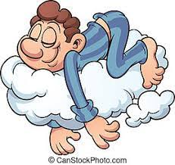


Everyone can do three things for good mental wellbeing:
Worksheet 14
Mental Health Awareness
Get Good Sleep
Eat Well
Exercise
The benefits that come with all three are powerful and, combined, can also help ease symptoms of mental illness. In some cases, they can even prevent disorders from developing. Be kind to yourself and remember that you might not find it easy to accomplish everything each week – but that’s ok!
A healthy habit: Exercise can help build resilience to life’s challenges and be a healthy way to cope with symptoms of mental illness. Movement is one of the most effective things to keep in your treatment toolbox.
More energy: Getting your heart pumping will give you a natural boost. Over time you’ll likely see you generally have more energy. This extra energy is helpful when you find it hard to get moving and lack motivation.
Sounder sleep: Any movement in the day can help with regulating sleep patterns. For evenings, try relaxing activities such as stretching or yoga – you can find specific stretches or postures online that will help promote better sleep.
A sense of achievement: Getting regular exercise that becomes a habit can feel incredibly rewarding. Over time, you’ll build a sense of self-worth, making you feel more confident and stronger (mentally and physically). The beauty of movement is that even the smallest of activities will leave you feeling better.
Decreased stress: Exercise reduces stress hormones (like cortisol) while increasing endorphins, giving you a natural boost.
Improved focus and memory: Those feel-good endorphins also help with concentration. Physical movement stimulates the growth of new brain cells, which can help prevent memory loss. You might find that while exercising, you’re distracted from intrusive thoughts and negative emotions. Some find physical activity a positive way to take their mind off worries.
A great way to connect: Having support helps ease the load of mental health challenges and illness. So, taking part in a class or signing up for a team sport is a great way to feel you’re not isolated, all while you get your dose of mood-boosting endorphins.
Better confidence: With the physical benefits coming into play, you might find a new sense of confidence. You may have more of a glow, a better posture, and a more vital stride. You may feel more confident in your own skin.
Exercise and your mental health: As well as the physical benefits, exercise can help improve sleep quality, energy, and mental health. Movement is also a powerful way to reduce the risk of developing mental illness and easing symptoms. This includes depression, anxiety, Post-Traumatic Stress Disorder (PTSD), panic disorder, and Attention-Deficit/Hyperactivity Disorder (ADHD). With many benefits, it’s clear to see why exercise is great for boosting your mental health. In some cases, exercise is prescribed as a treatment for mental illness.
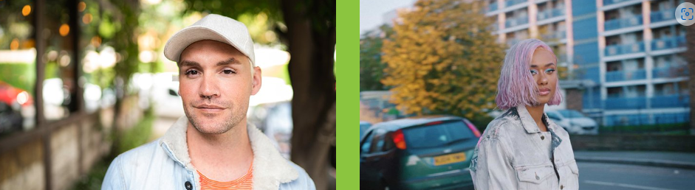
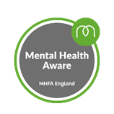
Top Tips to Improve Wellbeing
We all need good mental health and wellbeing – it’s essential to living happy and healthy lives. See 7 areas of life where simple change can make a big difference.
You can find lots of useful information and help on the NHS website below. Take the online quiz and get you free Mind Plan.
https://www.nhs.uk/every-mind-matters
Self-care for young people
Let’s be honest; its been a tough few years for us all. Taking steps to take care of our mental health is really important, and can help us lead happy and healthy lives, and cope with life’s challenges.
Mental wellbeing tips
We all need good mental health and wellbeing – it's essential to living happy and healthy lives, and can help us sleep better, feel better, do the things we want to do and have more positive relationships. It can also help us deal with difficult times in the future.
Every Mind Matters
Be kind to your mind.
There are small things we can all do to help be kind to your mind, and these can make a big difference to how we feel. Get expert advice and practical tips to help you look after your mental wellbeing and make them part of your daily routine.
Your Mind Plan Quiz
Answer 5 quick questions to get your free plan with tips to help you deal with stress and anxiety, improve your sleep, boost your mood and feel more in control.
Self-help CBT Techniques
Find out what CBT is, watch video guides and try practical tips and strategies to help deal with worries, solve problems and boost your mental wellbeing.
Dealing with life's challenges
We all go through difficult times, and it can be a healthy reaction to feel negative emotions when facing challenges. There's no single "right way" to react, and some of us are more deeply affected by events than others. Everyone is different.
Our genes, life experiences, upbringing and environment all affect our mental health and influence how we think and respond to situations. It can also depend on how well other parts of our life are going or how supported we feel. Being aware of these factors may make it easier to understand when we, or someone we care about, are struggling.
Find out more about what can affect our mental health, as well as lots of things you can do and organisations that can help.

Questions
- What are 5 mental health issues?
- What causes mental health issues?
- How do I know if I’m unwell?
- What do I do if I’m worried about my mental health?
- What do I do if the support doesn’t help?

